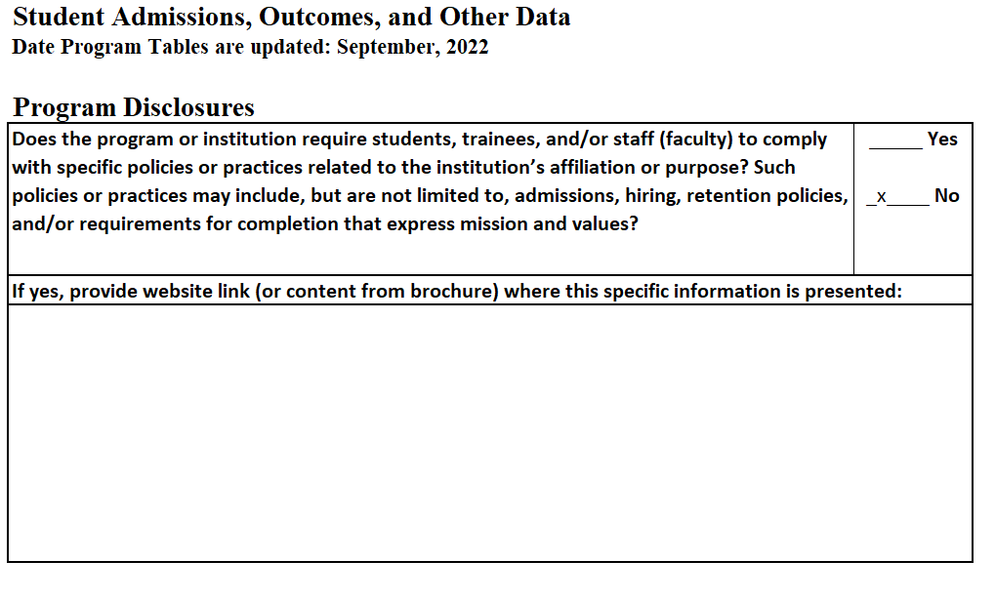

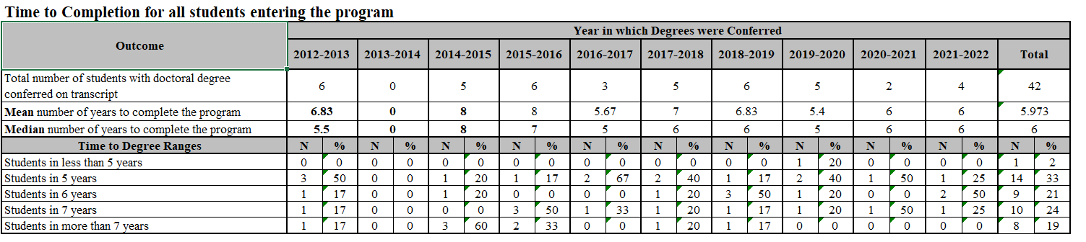
Also, please describe or provide a link to program admissions policies that allow students to enter with credit for prior graduate work, and the expected implications for time to completion. Please indicate NA if not applicable:

Please refer to page 33 of the Counseling Psychology Student Handbook for information on waiving equivalent courses in prior graduate work. The handbook can be located at https://cehs.unl.edu/edpsych/counseling-psychology/.

