COVER PAGE

Nebraska Department of Education Rule 24 Report
 | special education: Early childhood special education
(Content Area)
Educator Preparation Content Program Review

Name of institution | University of Nebraska-Lincoln
Date Submitted | 3.20.2017
Contact Person | Thomas Wandzilak
Phone/Fax | 402-472-8626
Email | twandzilak1@unl.edu

 | Folio type: |  | Regular |  |  | Mini |  |  | x | Advanced Program
Program(s) Covered by this Folio Press tab in last column to add rows
Endorsement(s) | Type | Grade Level | Program Level
List Endorsements | Subject | B-K | Post-Baccalaureate  Master’s
Early Childhood Special Education  Early Intervention Specialist | Subject  Supplemental | B thru K  B-K | FOR BOTH:  Masters Degree and/or  Graduate Certificate ECSE

Is the endorsement offered at more than one site? |  | Yes | X | No
If yes, list additional sites where endorsement is offered:

Institution Accreditation Status: |  |  |  |  |  |  | X | National |  |  |  |  |  | X | State
Is this a Nationally Accredited Program? |  |  |  |  |  |  |  |  |  | x | Yes |  | No
If Yes, list Accrediting Organization: |  |  |  |  | CAEP |  |  |  |  |  |  |  |  |  |  | Attach National Letter to Cover Sheet

Report to the Nebraska Department of Education
University of Nebraska—Lincoln
Folio Initial Level—June 2017

NDE Rule 24
006.62 Early Childhood Special Education
006.63 Early Intervention Specialist

INTRODUCTION AND WELCOME
Information about UNL’s offerings for teacher endorsements in early childhood special education (ECSE) or Early Intervention Specialist (EI-Sp) can be found at:

http://cehs.unl.edu/secd/early-childhood-special-education/
and
http://cehs.unl.edu/secd/frequently-asked-questions-ecse/
and
http://www.unl.edu/gradstudies/prospective/programs/Cert_EarlyChildhoodSpecialEd
and
http://cehs.unl.edu/documents/secd/handbooks/GradCertHndbk2016.pdf
and
http://cehs.unl.edu/documents/secd/handbooks/MASpEdHandbook.pdf
and
http://www.unl.edu/gradstudies/prospective/programs/SpecialEdAndCommDisorders
and
http://online.nebraska.edu/program/university-of-nebraska-lincoln-special-education-early-childhood-special-education-birth-k-endorsement-1452025734264
and
http://online.nebraska.edu/program/university-of-nebraska-lincoln-special-education-early-intervention-specialist-birth-k-endorsement-1452025734263

The link to the Rule 20 Folio is:
http://cehs.unl.edu/cehs/nde/Rule20.pdf

SECTION 1: CONTEXTUAL INFORMATION NARRATIVE

Section 1a: Endorsement Programs
University Mission Statement ion Statement
The University of Nebraska-Lincoln (UNL), chartered by the Legislature in 1869, is the part of the University of Nebraska system that serves as both the land-grant and the comprehensive public University for the State of Nebraska.

Through its three primary missions of teaching, research, and service, UNL is the state's primary intellectual center providing leadership throughout the state through quality education and the generation of new knowledge. UNL's graduates and its faculty and staff are major contributors to the economic and cultural development of the state. UNL attracts a high percentage of the most academically talented Nebraskans, and the graduates of the University form a significant portion of the business, cultural, and professional resources of the state. The quality of pre-kindergarten, primary, secondary, and other post-secondary educational programs in the state depends in part on the resources of UNL for curricular development, teacher training, professional advancement, and enrichment activities involving the University's faculty, museums, galleries, libraries, and other facilities. UNL provides for the people of the state unique opportunities to fulfill their highest ambitions and aspirations, thereby helping the state retain its most talented youth, attract talented young people from elsewhere, and address the educational needs of the nontraditional learner.
The University of Nebraska-Lincoln has been recognized by the Legislature as the primary research and doctoral degree granting institution in the state for fields outside the health professions. Through its service and outreach efforts the University extends its educational responsibilities directly to the people of Nebraska on a statewide basis.

The UNL College of Education and Human Sciences History
The College of Education and Human Sciences (CEHS) was founded on August 18, 2004, by Teachers College and The College of Human Resources and Family Sciences, with each founding college contributing extensive history and tradition. The College of Education and Human Sciences offers excellent educational advancement to both undergraduate and graduate students, serving approximately 2,800 undergraduates and 1,000 graduate students each year.

Education courses first became a part of the University curriculum in 1895 with the organization of a Department of Education designed to prepare students for teaching careers. On Valentine’s Day, 1908, the Board of Regents established a Teachers College. The college changed its name in 2004 to the College of Education and Human Sciences (CEHS). Over all this time, the College has been highly respected for its programs preparing teachers, administrators, and specialists for the education of children, youth, and adults. The quality of these programs is reflected in outstanding educational leadership in communities across the state and in the nation in teaching, administration, communication disorders, special education, and educational psychology.

The UNL Department of Special Education and Communication Disorders
The Department of Special Education and Communication Disorders (SECD) is one of seven academic departments in the College of Education and Human Sciences (CEHS) at the University of Nebraska-Lincoln (UNL). It has teaching, service/outreach, and research functions and a statement that describes its mission.
SECD is dedicated to enhancing the lives of individuals with special needs, and their families, schools, and communities. SECD’s vision is that every individual with special needs will: 1) achieve maximum potential for learning; 2) communicate autonomously; and 3) enjoy optimum health and well-being throughout the lifespan.
The program in Special Education prepares educators with the knowledge and skills to improve the academic, social, and life outcomes for children, youth, and adults with disabilities, and for their families.

Advanced Teacher Education Programs in Special Education
In SECD, three advanced programs lead to subject endorsements by the Nebraska Department of Education: Early Childhood Special Education (ECSE), Deaf and Hard of Hearing Education (DHH), and Visual Impairment (VI), and two supplemental endorsements: Behavior Intervention Specialist and Early Intervention Specialist (EI-Sp). In ECSE, the degree and graduate certificate options encompass coursework and supervised fieldwork applicable to both the ECSE (birth thru K) and EI-Sp (birth to K) endorsements.

1b. Standards of Admission, RETENTION, TRANSITION, AND COMPLETION for ECSE endorsements

Admission to the University of Nebraska-Lincoln
An applicant with any of the following is eligible for graduate admission:
- A four-year U.S. bachelor's degree from a regionally accredited college or university.
- An equivalent degree as evaluated by the University of Nebraska-Lincoln Office of Graduate Studies.
- UNL senior standing within 9 hours of graduation. See Hold for Graduate Credit.
The Graduate College (UNL Graduate Studies) is open to graduates of all colleges of this University and to graduates of other universities and colleges of recognized standing whose requirements for graduation are substantially the same as those in the corresponding colleges of this University. The University of Nebraska is a public university committed to providing a quality education to a diverse student body. Students are selected on the basis of academic preparation, ability, and the availability of space in the desired academic program.
It is the policy of the University of Nebraska-Lincoln not to discriminate based on gender, age, disability, race, color, religion, marital status, veteran’s status, national or ethnic origin, or sexual orientation.
- Applicants must have earned a bachelor's degree or higher from an institution that is regionally accredited, an institution that is accredited by an organization recognized by the Council on Higher Education Accreditation (CHEA), or from an accredited foreign institution that is recognized by Graduate Studies.
- Acceptance for admission to a program leading to a masters degree, a doctoral degree, an educational specialist degree, or a certificate is determined by the Graduate Committee within the academic unit and the Dean of Graduate Studies. This decision is based upon the applicant’s record, experience, personal qualifications, and proposed area of study. Departmental or area Graduate Committees make recommendations on all degree applications, but the final admission decision is the responsibility of the Dean of Graduate Studies.
- Notification of acceptance by a department Graduate Committee or faculty member is advisory only. Admission is granted solely by the Office of Graduate Studies and is confirmed by the issuance of a Certificate of Admission. Academic departments will notify applicants concerning awards of financial assistance.
- Negative admission decisions are not appealable.

Admission to the Teacher Education Program (TEP) in Early Childhood Special Education
Prospective students must complete application to both the Graduate College and the Department of Special Education and Communication Disorders as a degree-seeking or graduate-certificate-seeking student. This entails submission of transcripts, a letter of intent, an application form, and three letters of recommendation. Graduate Record Exam (GRE) scores are needed for degree application. If students already hold an advanced degree in Education, they may apply to the Graduate College as a Graduate Certificate student. It is required that all interested students have their transcripts reviewed and get a possible program of study outlined and questions answered before applying.

The Special Education Graduate Admission Committee in the Department of Special Education and Communication Disorders reviews all applications for the Masters degree once each year with an application deadline date of January 15th. The Committee determines the admission status of applicants. Applicants are accepted as a Degree Candidate with Full Graduate Standing or granted “Provisional Admission” pending satisfactory completion of nine graduate credits from UNL Special Education courses with a B or better in each course; additional requirements are possible. Once these specified requirements have been met, the candidate’s academic status is changed to “Full Graduate Standing” in the degree program. The academic status level is specified in the student’s admission letter.

Applications for a Graduate Certificate option are reviewed year round once all required application materials are received. The Special Education Graduate Admissions Committee determines the admission status of applicants. Applicants are accepted or denied admission; there is no “provisional admission” status for the Graduate Certificate option. Requirements for admission to the Graduate Certificate in ECSE include a minimum GPA of 3.0, an application form, three letters of recommendation regarding the applicant’s ability to successfully complete and benefit from graduate courses, and evidence of successful completion of one course in special education. Applicants with a Masters degree in Special Education will have the requirement for letters of recommendation waived. Students who begin study for a Graduate Certificate can apply at a later date for admission to the Masters Degree program in Special Education.

Retention
Students must maintain a minimum grade point average (GPA) of 3.0 while pursuing the Master’s Degree in Special Education. Furthermore, the minimum course grade permitted for graduate credits to be used toward a Masters Degree (courses on the Memorandum of Courses: MOC) varies with the level of the course and whether a course is in or outside the major, specifically:

For 400/800 level courses in SpEd: a minimum grade of B is allowed;
For 800 only or 900 level courses in SpEd: a minimum grade of B- is allowed; more than two courses below a B‐ will be cause for academic dismissal from the degree program;
For 800 only and 900 level courses outside SpEd: a minimum grade of C is allowed for degrees; a B‐ or lower in a course designated for an Option II minor requires student to complete a comprehensive minor exam.
Must meet criminal history requirements at all times. PASS/NO PASS option permitted only in 800-­‐only and 900 level courses in SpEd.

Students pursuing a Graduate Certificate in ECSE must maintain a GPA of 3.0. No class with letter grade below B- can be used toward the Certificate.

The Student Advising Sheet
The UNL requirements for the ECSE and EI-Sp graduate programs are listed on the respective advising sheets in Figures 1 & 2.

Transition Points
A summary of the transition points through the ECSE graduate program can be found in the Appendix in Table 2.

Requirements to Complete the Graduate Degree Specialization or Graduate Certificate in ECSE
- Successful completion of all required coursework.
- Successful completion of Sped 896Q (3 credits) and associated field experiences.
- Address all financial obligations tied to the University of Nebraska-Lincoln.
- Successful completion of the Exit Examination for the Masters Degree.
- Apply for the degree. Students must apply for graduation during the first weeks of the semester in which they intend to graduate. Students may be completing the Exit Examination for the Masters Degree during the same semester they plan to graduate, but the Application for Graduation must be on file before the exam is completed; failure to pass the department Exit Examination will require a delay in graduation and a new application during a subsequent semester in which the student hopes to retake the exam and graduate.
Note: There is no application form for completion of Graduate Certificate requirements. Once Certificate courses are completed (12 credits), candidates are to contact their academic advisor who will in turn notify the Office of Graduate Studies. The Graduate Certificate in ECSE will be reflected on the transcript.
- Successful completion of specialty exam (Praxis #5691) for ECSE endorsement.
Note: No PRAXIS exam is required for EI-Sp endorsement.

Application for Exit Exam/Final Examination Report for Degree Students
All students are to complete Part 1 and Part 2 of the UNL Graduate College Final Examination Report Form and submit it to their academic advisor early in the semester in which they plan to take the department Exit Exam and they plan to graduate. The academic advisor will submit the Final Examination Report as the student’s “application” along with approved exam questions/instructions to the Department Graduate Secretary no later than the deadlines outlined in the table below that explains the Exit Examination process.
http://www.unl.edu/gradstudies/current/degrees/masters

Exit Examination. The purpose of the exit examination for a Masters Degree student is to assess the student’s ability to integrate information from completed coursework and their ability to synthesize/analyze published literature to support their professional decisions as special educators. All students pursuing Option II (M.A./M.Ed.) or III (M.A.) in the Masters Degree Program in Special Education must complete an exit exam, as well as completing all courses on the MOC with a passing grade in order to meet requirements of the degree program. Students pursuing Option I will have the Thesis serve as their exit examination. The design of the exit examination will be completed with input from the student’s academic advisor. To be eligible to take the exit exam, a student must have a MOC on file with UNL Office of Graduate Studies and have completed at least 30 credits of the 36+credit degree program and have the agreement of their academic advisor. If a student has declared an area of specialization, the exit exam is meant to assess the student’s ability to synthesize information related to their area of specialization.

1c. Field Experiences
Field experiences in ECSE graduate programs are completed with infants, toddlers, and preschool-age children and their families and can include home-based and center-based programs serving children who have verified disabilities, with their families and other personnel responsible for their care and education. A minimum of 100 (ECSE subject endorsement) or 180 (EI-Sp supplemental endorsement) clock hours working with young children, ages birth to 5, including those with special developmental and/or learning needs is required. At least 20 (ECSE) or 80 (EI-Sp) clock hours will be spent assisting families and children with verified disabilities at: birth up to age 3 and ages 3 to 5. For the ECSE endorsement, an additional minimum of 20 clock hours are required with children at kindergarten or ages 5 to 7.
Field experiences include, but are not limited to: (a) assessment practices that include observations, interviews with adults, and direct testing; (b) the preparation of visit or classroom activity plans and materials for coaching and/or teaching; (c) the coaching of adults and/or teaching children; (d) documentation for formative and summative evaluation; (e) attending meetings (faculty/staff, IFSP, etc.); and (f) collaborating with families, schools, and community agencies where necessary, all under the guidance of an instructor, university supervisor, and/or approved cooperating teacher onsite.

Please see Table 3 in the Appendix for a summary of the Field Experience hour requirements associated with each practicum course and the related endorsements.

1d. Program Completers

Table 4—Program Completers

Program Completers and Level – Content Area
Academic Year |  |  |  |  | Number of Endorsement Program Completers
 |  |  |  |  | Bac | Post Bac | Alternate Route | Masters | Ed. Specialist | PhD
20 | 14 | to | 20 | 15 | 0 | 1 |  | 3
20 | 15 | to | 20 | 16 | 0 | 0 |  | 6

SECTION 2: ENDORSEMENT PROGRAM KEY ASSESSMENTS AND RELATED DATA

Artifact 1

Table 5
Summary Table of Endorsement Program Key Assessments
ADVANCED PROGRAM:
006.62 Early Childhood Special Education
006.63 Early Intervention Specialist
Data for 2014-2015, 2015-2016 Academic Years

 | Name of Assessment | Type or Form of Assessment | Brief Description of Assessment | When Assessment is Administered | Data  2014-15 /  2015-16
1 | Content (Rule 24/CEC Initial Standard #3,  Advanced Standard #2; EI-Sp Standard #4)
 | Cumulative GPA | Summative | Numerical computation of grades based on  quality points earned divided by credit  hours completed |  | Graduation GPA  2014-15  M =3.67 (s.d. .3)  2015-16  M=3.74 (s.d. .15)
 | Praxis II #5691 | Comparison to a Standard | National ETS exam for ECSE focus (birth to K).  Passing scores of 159+ | No sooner than two semesters before completion of program requirements; can be taken anytime after completion of program | 2014-15  2 students completed exam and passed w/score > 159  2015-16  5 students completed exam and passed w/score > 159
 | Assessment Reports and Goal Planning | Formative | Sped 862 summary of assessment data and justification for targeted goals and learning environments and adaptations.  Passing scores > 80% | Mid semester of Sped 862; generally Fall of second year in program | 2014-15  2 Passed w/ scores > 80%; 2 scored 70-79%  2015-16  5 passed w/scores > 85%; 1 =67%
 | Teacher Candidate’s Practicum/Student-Teaching Experience  FINAL RECOMMENDATION | Summative | Rating of acceptable, basic, or proficient on seven CEC standards and a written narrative describing experience, growth, and professional development needs. | End of SPED 896Q | 2014-15  4 students showed Proficient skills in this area  2015-16  6 students showed Proficient skills in this area
2 | Knowledge of Learner/Learning Environments (CEC Initial Standards #1, 2; EI-Sp Standards #1, 2, 3)
 | Philosophy Statements | Formative | Statement of beliefs regarding quality early intervention and education for children with disabilities reflecting recommended and evidence-based practices, as well as theory and national laws and state rules.  Passing scores > 3.5 on 4.0 scale | Sped 860; generally first year | 2014-15  4 passed w/scores >3.5  2015-16  6 passed w/scores > 3.6
 | Developmental Care Plans | Summative | Having observed a infant with special needs, students draft a plan for care-providers to implement that is written in baby’s voice and describes how to approach, interact and stimulate child only when alert and calm  Passing scores > 80% | Sped 863; generally summer of first or second year | 2014-15  2 passed w/scores 85-100%; 2 scored 75-80%  2015-16  6 passed w/scores 92-100%
 | Classroom Observations | Summative | Using a national observations scale, students will document quality of preschool or kindergarten learning environments and interpret results and make recommendations for improvement based on knowledge of recommended practices  Passing scores > 1.5 on 2.0 scale | Sped 896Q | 2014-15  4 students passed w/scores 2.0  2015-16  6 passed w/scores 2.0
 | Family Interviews | Summative | Over weeks, in person and electronically students complete ongoing interviews, with parents of a school-age child with disabilities. This helps students understand family life with a child with disabilities.  Passing scores > 80% | Sped 960 | 2014-15  3 passed w/scores 93-100%; 1 scored 73%  2015-16  5 passed w/scores 85-100% ; 1 scored 73%
 | Teacher Candidate’s Practicum/Student-Teaching Experience  FINAL RECOMMENDATION | Summative | Rating of acceptable, basic, or proficient on seven CEC standards and a written narrative describing experience, growth, and professional development needs. | End of SPED 896Q | 2014-15  3 students showed Proficient skills in this area;  1 student showed Basic skills  2015-16  3 students showed Proficient skills in this area;  3 students showed Basic skills
3 | Knowledge and Effective Use of Professional Practices (CEC Initial Standards #4, 5, 6; Advanced Standards #1, 3, 4, 5; EI-Sp Standards #5, 6, 8)
 | Assessment Reports | Formative/Summative | Summary of shared observations of child and interview data with care-providers; interpretation of strengths and needs developmentally and functionally for routine learning environments and partners.  Passing scores > 80% | Sped 861 (infants) & 862 (preschoolers);  896Q requires repeat with a second for each age group | 2014-15  2 Passed w/ scores > 80%; 2 scored 70-79%  2015-16  5 passed w/scores > 85%; 1 =67%
 | Instructional Plans | Formative | Detailed plan of instruction/intervention based on assessment information; includes target behavior, evidence-based and justified strategy and hierarchical use/fading of prompts and reinforcers  Passing scores > 12.5 of 15 pts possible | Sped 862; repeated for two goals | 2014-15  3 passed w/scores 13+ pts; 1 = 11pts  2015-16  3 passed w/scores 13.5+ pts; 3 = 11 pts
 | Home Visiting Plans | Formative | Based on assessment data and previous reflections of HV practice, this is a detailed plan for how to approach interviewing coaching and teaching during Opening, Closing and the Main event/focus of upcoming visit with parent and child. To advance competence and confidence in both  Passing scores > 12.5 of 15 pts possible | Sped 861; repeated a minimum of 6 times | 2014-15  3 passed w/scores of 12.5+ pts.; 1 = 11 pts.  2015-16  5 passed w/scores 12.5+ pts; 1 = 11.5 pts
 | Teacher Candidate’s Practicum/Student-Teaching Experience  FINAL RECOMMENDATION | Summative | Rating of acceptable, basic, or proficient on seven CEC standards and a written narrative describing experience, growth, and professional development needs. | End of SPED 896Q | 2014-15  3 students showed Proficient skills in this area;  1 student showed Basic skills  2015-16  3 students showed Proficient skills in this area;  3 students showed Basic skills
4 | Professional Responsibility and Overall Proficiency (CEC Initial Standard #6, 7; Advanced Standards #4, 5, 6, 7; EI-Sp Standards #7, 8)
 | Home Visiting Self Reflections | Formative | Guided reflection on key components and behaviors for a quality Home Visit  Passing scores > 12.5 of 15 pts possible | Sped 861  After each of 8+ home visits | 2014-15  4 passed w/scores 12.5+ pts  2015-16  5 passed w/scores 13+ pts.; 1 = 10 pts.
 | Progress Reports | Formative | Data-based summary of goal-specific intervention implemented over 4-6 weeks; reflection on what worked, why and what was learned.  Passing scores > 80% | Sped 861/862 | 2014-15  3 passed w/scores 98-100%; 1 = 75%  2015-16  5 passed w/scores 90-100%; 1 = 79%
 | Transition Policy | Summative | Review of district policy for transitions between settings, funding sources, schedules, locations, or providers, for children birth to age 5; Proposal of transition policy or amendments based on DEC recommended practices  Passing scores >1.5 of 2.0 pts pssible | Sped 896Q | 2014-15  2 passed w/ scores 2.0 pts; 1 = 1.2 pts; 1 = NA  2015-16  3 passed w/scores 2.0 pts; 2 = 1.0 pts; 1 = N/A
 | Teacher Candidate’s Practicum/Student-Teaching Experience  FINAL RECOMMENDATION | Summative | Rating of acceptable, basic, or proficient on seven CEC standards and a written narrative describing experience, growth, and professional development needs. | End of SPED 896Q | 2014-15  4 students showed Proficient skills in this area;  2015-16  4 students showed Proficient skills in this area;  2 students showed Basic skills

SUMMARY of DATA. The 10 graduates of the ECSE program at UNL from 2014-2016 demonstrated competence on all or most of the transition assessments listed in Table 2. Nine of the 10 graduates completed a Masters Degree and one exited the program after completion of the endorsement requirements.

The 10 graduates had an average GPA over 3.5 (s.d. .15-.3). All seven who took the national PRAXIS-II test had scores exceeding PASS cut-off scores; three students during this period were not required to take the national PRAXIS-II test because they completed their program before the test was required by NDE, were not required to take the test for their specific endorsement (EI-Specialist), or did not pursue the Masters Degree, which had required the test prior to NDE requirements. The results of the PRAXIS-II and the documented GPAs suggest UNL’s graduates for the ECSE program exceeded expectations nationally and had successful academic careers. The student with the lowest GPA (3.3) was the one student who did not pursue a Masters Degree.

Formative assessments were used to determine student progress toward competence and graduation. In four of these six assessments 80% of the students received a passing grade. For assessing young children’s abilities and drafting instructional plans, only 60-70% received the passing grades midway through their program. But these students did show emerging skills with scores 67-80% or 11 to 13 pts. of 15 pts. possible on these assignments. Subsequently, over 75% of the graduates received ratings of Proficient in all areas on summative assessments of their skills, whereas 25% received ratings of Basic in a few areas. No student was rated Unsatisfactory in any area when exiting the program.

SECTION 3: USE OF RELATED DATA AND INFORMATION FOR CONTINUOUS PROGRAM IMPROVEMENT OF ENDORSEMENT PROGRAM

The ECSE and EI-Specialist endorsement programs, as currently outlined in Rule 24, have not been reviewed previously as both are relatively new (August 2014). The ECSE endorsement replaces the old Preschool Disabilities endorsement (Birth to K) and upgrades previous requirements for the old ECSE endorsement (Birth to Grade 3). Now these subject (ECSE) and supplemental (EI-Sp) endorsements both focus on children birth to K. The ECSE-endorsement changes require consideration of kindergarten age programs, with intent to inform ECSE teachers for more successful transitions from preschool to kindergarten. NDE Rule 24 Guidelines for this endorsement explicitly state that the ECSE teacher will not be qualified to teach as lead teacher in kindergarten classrooms.

The NDE Rule 24 Guidelines for EI Specialist endorsement refer to the same national standards (CEC/DEC) used for the ECSE endorsement. The differences in these two endorsements are minimal but notable. There is the need for the EI-Sp candidate to have K-6 Special Ed credentials and complete 6 fewer credits in child development/early education and 3 fewer credits in ECSE content courses than candidates for the ECSE endorsement. Finally, no PRAXIS exam is required for the EI-Sp candidate but is for ECSE candidates. The EI-Sp candidate, however, is required to aim for 80 contact hours with infants and 80 contact hours with preschool-age children with disabilities compared to 20-hour minimum (100 total) requirement for ECSE candidates.

The changes in endorsements during the past 2 years have prompted the need for adjustments in UNL ECSE program course requirements and the field work options and requirements and tracking of clock hours. For example, the ECSE endorsement candidates are required to complete 12 credit hours of child development/early education courses and include a course in kindergarten teaching (TEAC 810). This necessitated collaboration with colleagues in TLTE to develop/resurrect TEAC 810 and agree to offer it via distance education given the high number of distance learners in the ECSE program. The course will be offered alternate summers online.

Furthermore, the ECSE endorsement candidates are required to complete a minimum of 20 clock hours with kindergarten-age children with disabilities. This has proven challenging as (a) many candidates are employed full-time while pursuing the degree/certificate part-time and do not have options for extended field work in a kindergarten classroom beyond 1-2 observation sessions (2-3 hrs), (b) kindergarten programs are generally not available in summer sessions, and (c) organized field work for courses prioritize work with infants and toddlers, and ECSE cooperating teachers generally do not have assignments with kindergarten-age children, so a practicum placement would require agreement from a K-6 SpEd teacher, already tapped out with K-6 placements.

Since beginning to track clock hours in 2014-2015 it has become evident that most kindergarten hours are being accumulated as part of assignments associated with SpEd 882 requirements (severe disabilities) (6-11 hrs). This requirement will continue to be a challenge for all but traditional, unemployed, full-time graduate students (rare).

The log of clock hours for eight students who have completed programs between 2014 and 2016 reveals that most fall short of the required 100 or 180 clock hours and/or the minimum hours needed per age group. If students are already employed in ECSE positions, they can count hours associated with on-the-job experiences; this generally, however, means 400+ hours with preschool age children, not infants or kindergarten-age children. Student employment, enrollment status, and geographic location have influenced fieldwork clock hours and options for the age groups. The pattern to date is summarized in the table below.

Table X: Summary of ECSE and EI-Sp Candidates’ Clock Hours with Infants, Preschoolers, and Kindergarten-Age Children With Disabilities
Program | Employment | Enrollment | Geography | Infants  minimum: 80 hrs. | Preschool  minimum: 80 hrs. | K-level  (N/A) | Total  min: 160 hrs.
EI-Sp | FTE: K-6 | PTE | North Central Nebraska | 17 | 26 | 21hrs.  + 583 hrs.  on-the-job | 64 +  583
Program | Employment | Enrollment | Geography | Infants  minimum: 20 hrs. | Preschool  minimum: 20 hrs. | K-level  minimum20 hrs. | Total  Min: 100 hrs.
ECSE | FTE: ECSE- preschool | PTE | Mid Central Nebraska | 7+  20 TBA in summer ‘16 | 28  + 450  on-the-job | 11 | 66+  450
ECSE | FTE: ECSE-preschool | PTE | Omaha area | 10 | 1360  on-the-job | 3 | 13+ 1360
ECSE | FTE: ECSE-preschool | PTE | Omaha area | 7 | 5  + 1070  on-the-job | 5 | 17+ 1070
ECSE | No  (history of infant Head Start) | FTE | Lincoln/ Omaha | 10 | 52 | 0 | 62
ECSE | No  (history with infant child care) | FTE | Lincoln | 7 | 21 | 8.5 | 36.5
ECSE | No  (history with preschool childcare) | *FTE | Lincoln | 8+  (will student teach 8 wks) | 77+  (will student teach 8 wks) | 2 | 87+
ECSE | No  (no experience) | *FTE | Lincoln | 8+  (120 student teaching) | 88+  (144 student teaching) | 0 | 96+  (264+ student teaching for 16 weeks)
* students do not hold teaching certificate; working to earn initial teaching certificate as part of ECSE program and will therefore be required to complete a minimum of 16 weeks traditional student-teaching, 8 weeks each with infants and preschoolers in ECSE programs with ECSE-certified Cooperating Teachers.

As a result of these data, efforts are being made to revise requirements for Sped 896Q. Students will be asked to seek summer employment in ECSE infant programs in their community or agree to a practicum arrangement for a minimum of 10 hours of more infant contact.

REQUIRED RULE 24 FOLIO APPENDICES

Table 1
UNL Graduate Admission Requirements

Bachelor’s Degree or higher | From an institution that is regionally accredited, accredited by an organization recognized by the Council on Higher Education Accreditation (CHEA), or from a accredited foreign institution recognized by Graduate Studies.
Acceptance for admission to a degree or graduate certificate program. | Determined by the Graduate Committee within the academic unit and the Dean of Graduate Studies based on applicant’s record, experience, personal qualifications and proposed area of study.
Issuance of Certificate of Admission | By the Office of Graduate Studies

Table 2
Major Transition Points for ECSE–Related TEP Program Candidates

Acceptance into University | Acceptance into Teacher Education Program in ECSE | Acceptance into Field Experience Sped 896Q | Program Completion/  Graduation
--Bachelor’s degree or higher.  --Acceptance for admission to a degree or graduate certificate program  --Issuance of certificate of admission | --Admission to the Graduate College  --Admission to the Master’s Degree specialization in ECSE or Graduate Certificate in ECSE  --Minimum cumulative GPA of 3.0  --Current Teacher Certification (El Ed; ECE; IECE; SpEd K-6; Deaf Ed P-12; VI P-12; SLP P-12 ) | --Completion of SPED 860 with B or better  --Minimum cumulative GPA of 3.0  --Criminal history check | --Completion of required coursework with acceptable grades/GPA  --Successful completion of SpEd 896Q field experiences and  --Advisor submission of Final Recommendation Form  Passing of exit examination for the Master’s Degree  (if applicable).  --Meet all financial obligations  --Apply for the degree  --Notify Advisor of Certificate course completion  --Passing PRAXIS #5691 (ECSE–only)

Figure 1: Advising Sheet for Early Childhood Special Education (ECSE) Endorsement NDE Rule 24: 006.62 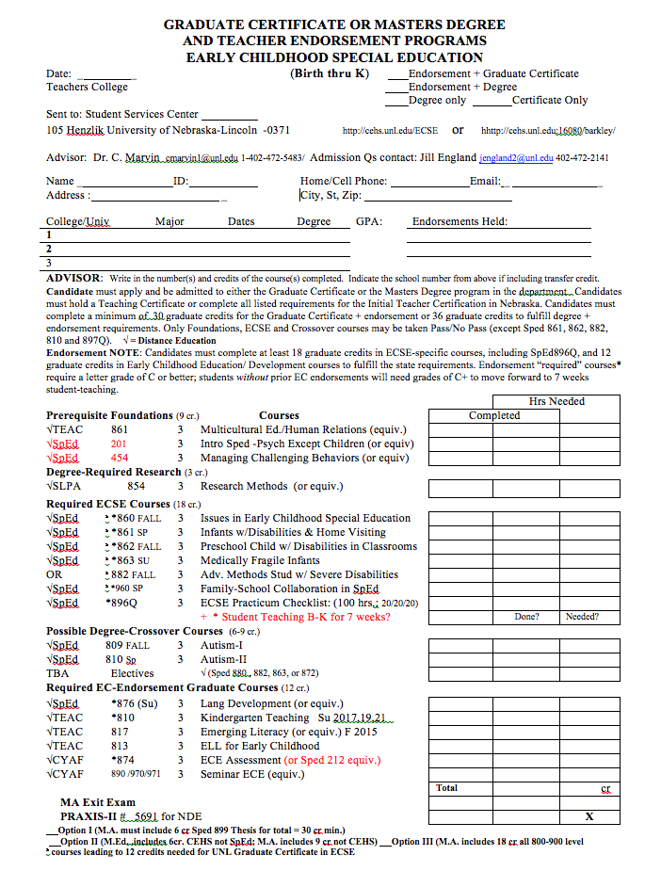
Figure 2: Advising Sheet for Early Intervention Specialist (EI-Sp) Endorsement
NDE Rule 24: 006.63
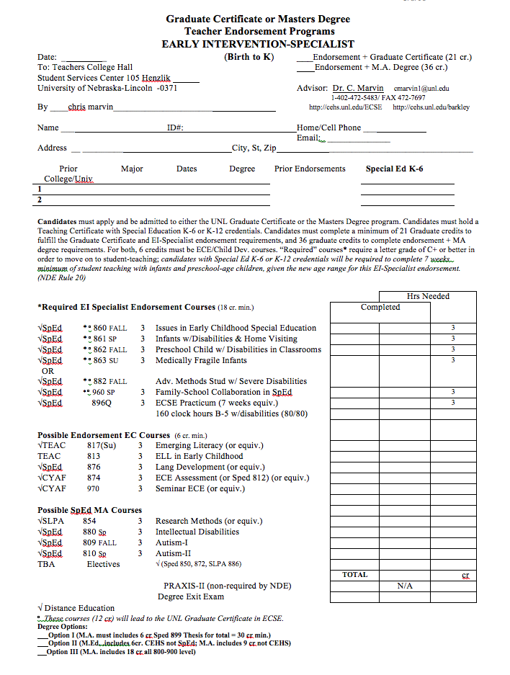
Table 3
Estimated Summary of ECSE Field Experience Clock Hours
Course | Cr | Days/Wk | Hrs/Day | Weeks | Total Hrs
Sped 860 | 3 | 1 | 2-5 | 2-3 | 4-15
Sped 861 | 3 | 1 | 1 | 10 | 10
Sped 862 | 3 | 1 | 2.5 | 14 | 35
Sped 882 | 3 | 1 | 1 | 8-10 | 8+
Sped 960 | 3 | 1+ | 1 | 4-16 | 6+
Sped 896Q | 3 | TBA | TBA | 64 | TBA
Total ECSE | -- | ----- | -------- | --------- | 100
Total- EI-Sp |  |  |  |  | 180

